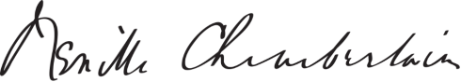

This is to certify that

Name Surname

Son/daughter of Shri _____________________________for the last _____________________

years _________________________________________ months and that to the best of me

knowledge and belief he/she bear reputable character and has no antecedents

which render him/her unsuitable for employment in Government of India

Undertaking.

Shri Shrimati/Kumari _____________________________________ is not related to me.

Place ___________________________________

Signature _______________________________

Date ___________________________________

Designation ___________________________

*(to be signed by anyone of the following)

1. Gazetted Officers of Central or State Government.

2. Members of Parliament or State Legislature belonging to the Constituency where the candidate or his parent/guardian is ordinarily residing.

3. Sub-Divisional Magistrate / officers

4. Tehsildars or Nayab / Deputy Tehsildars authorised to exercise Magisterial

Powers.

5. Principal / Headmaster of the recognized School / College / Institution

where the candidate studied last.

6. Block Development Officers.

7. Post Masters

8. Panchayat Inspectors.

Character Certificate