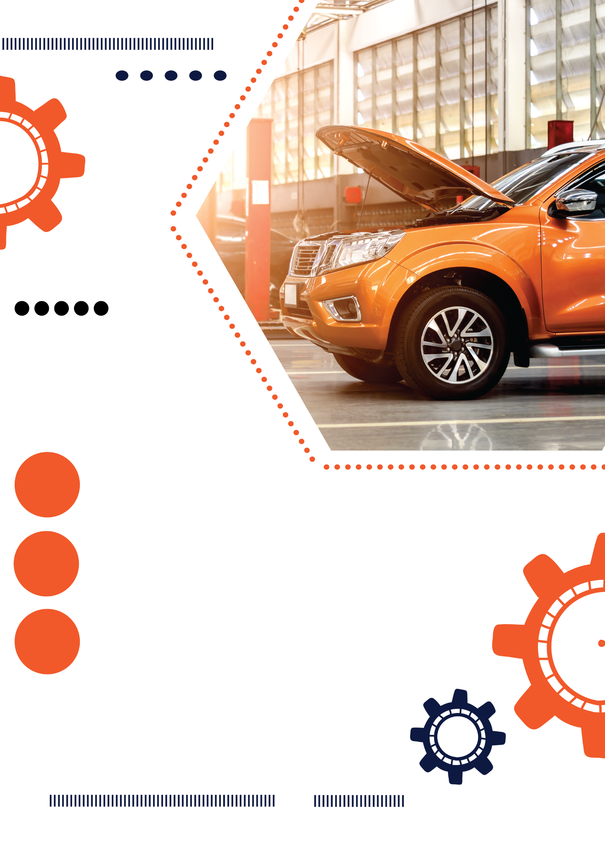

**$85**

**$65**

**$45**

**Premium Wash**

**Standard Wash**

wash / wax/ Dry / Tyre

Dressing / vacuum and

dash wip / polish

wash / wax/ Dry / Tyre

Dressing / vacuum and

dash wip / polish

**Basic Wash**

wash / wax/ Dry / Tyre

Dressing / vacuum and

dash wip / polish

Car Detailing List

Full service get discount

Lorem ipsum dolor sit amet, consectetuer adipiscing elit, sed diam nonummy nibh euismod tincidunt Lorem ipsum dolor sit amet, consectetuer adipiscing elit, sed diam nonummy nibh

**0123 456 789**

your location here / website here

**$225**

**$125**

**$255**

**$125**

**$265**

**$135**

**Full Detail**

**Pre-sale Detail**

**Custom Detail**

**Interior Shampoo**

**Detail & Polish**

**Cut & Polish**

Car Wash & Auto Detailing Specialist

Professional

Car Service