

Weekly To Do List

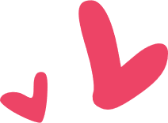

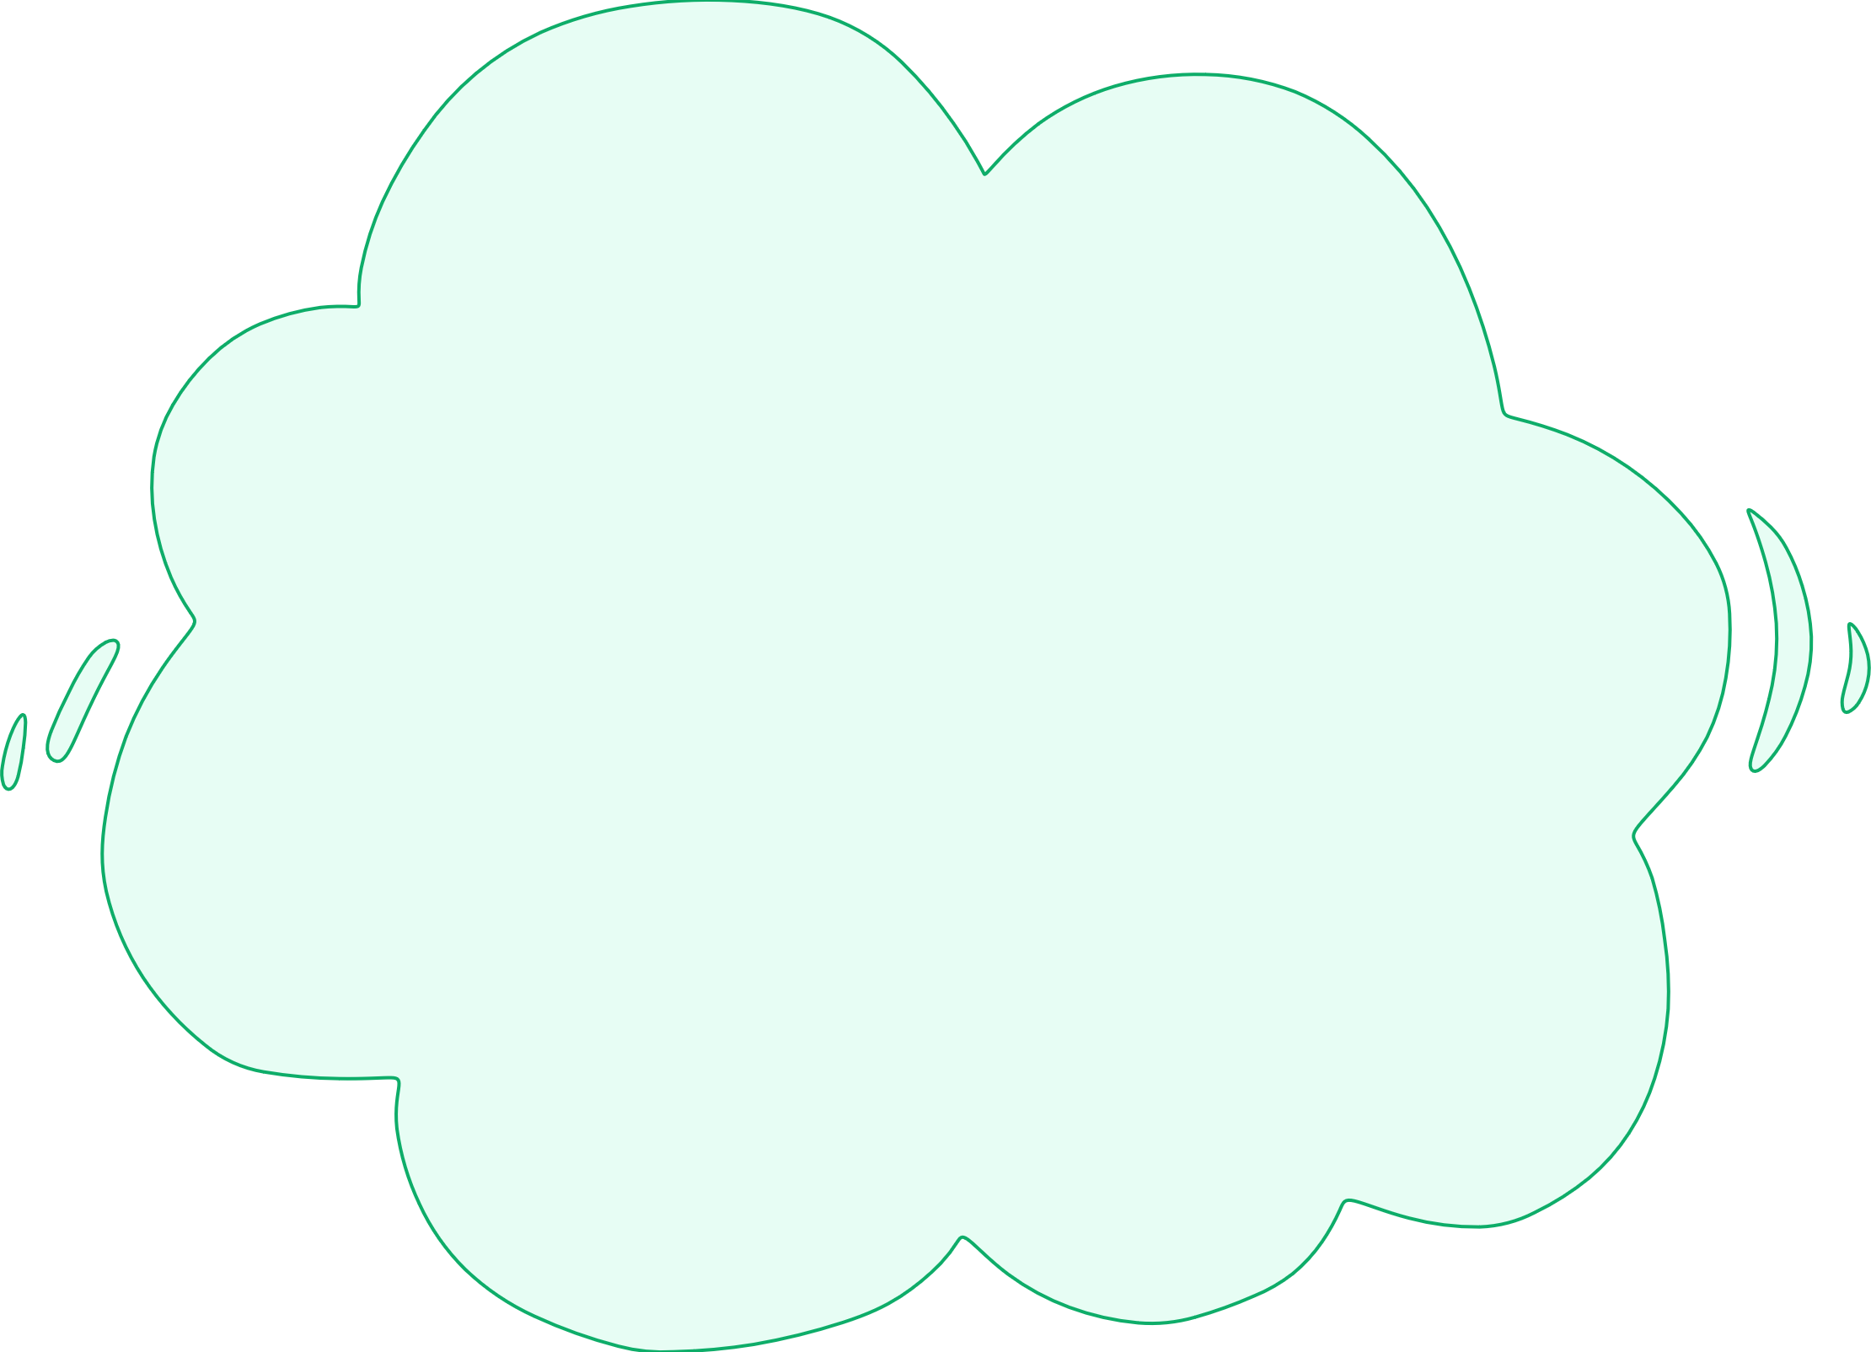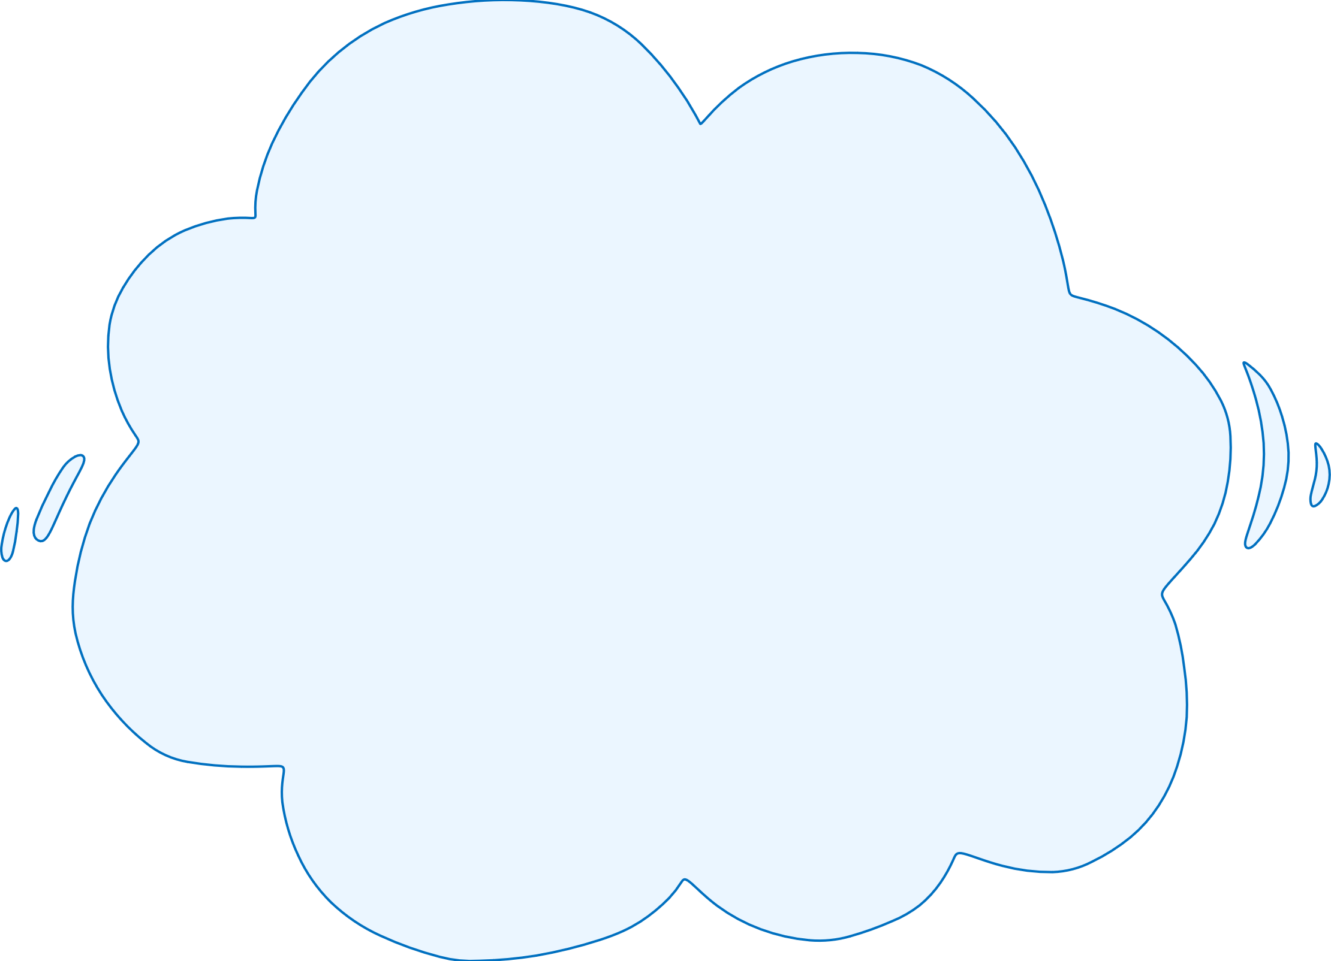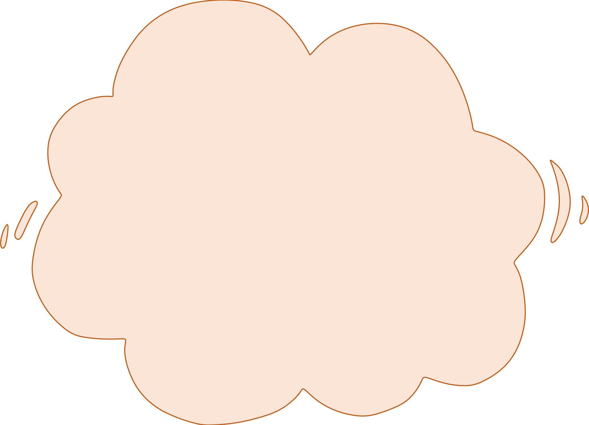

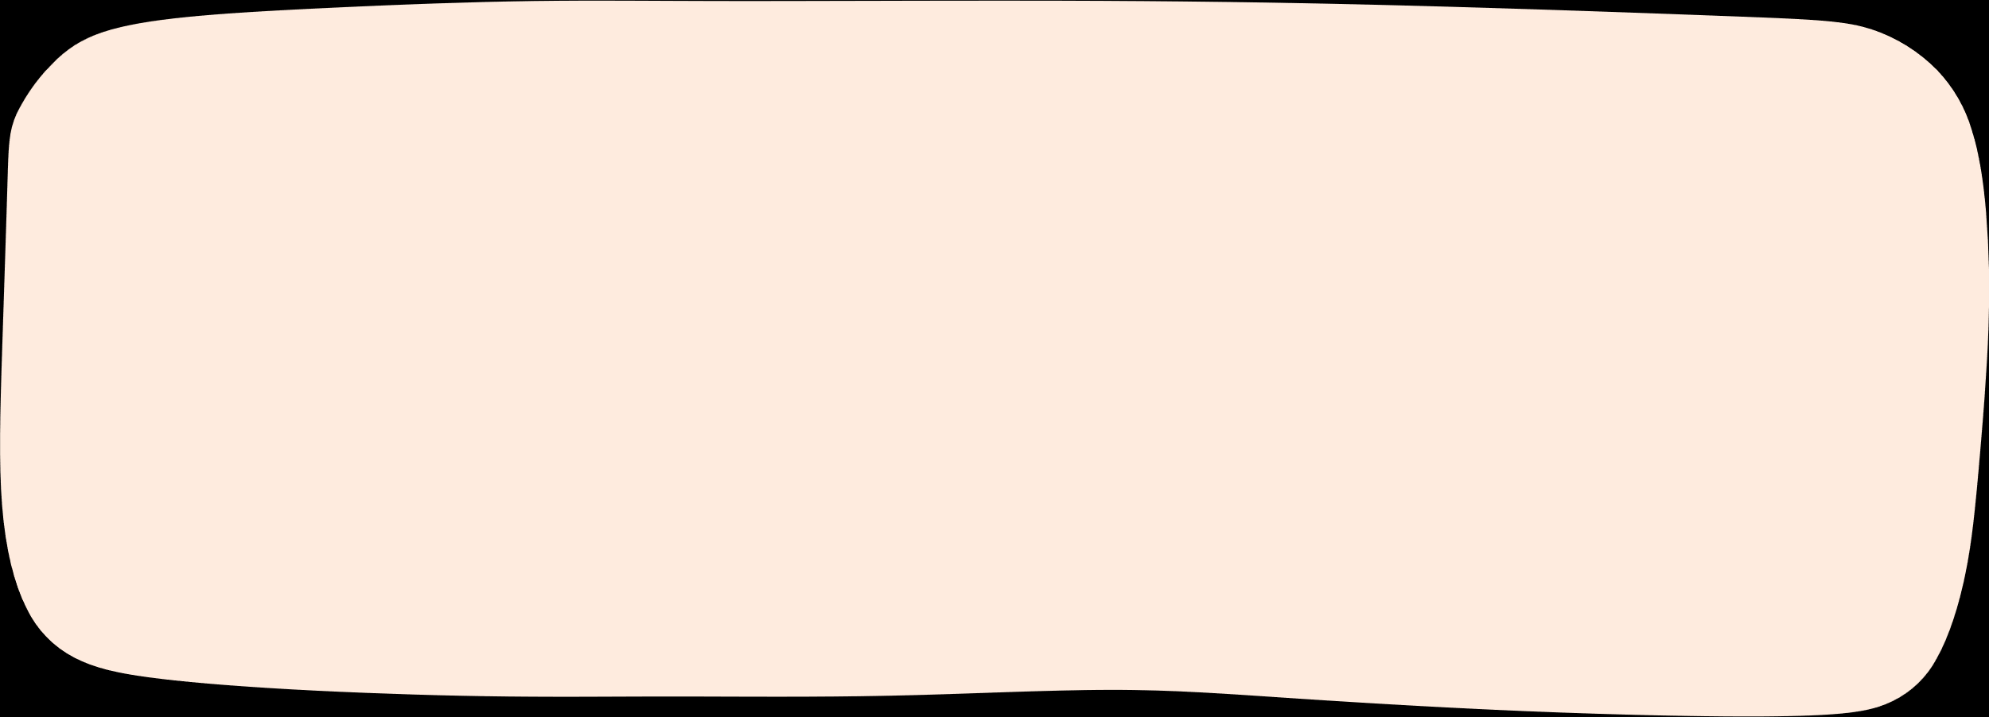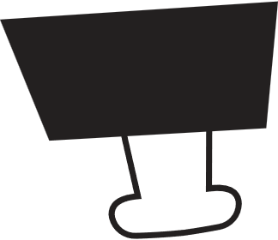

Notes



Thursday



Monday

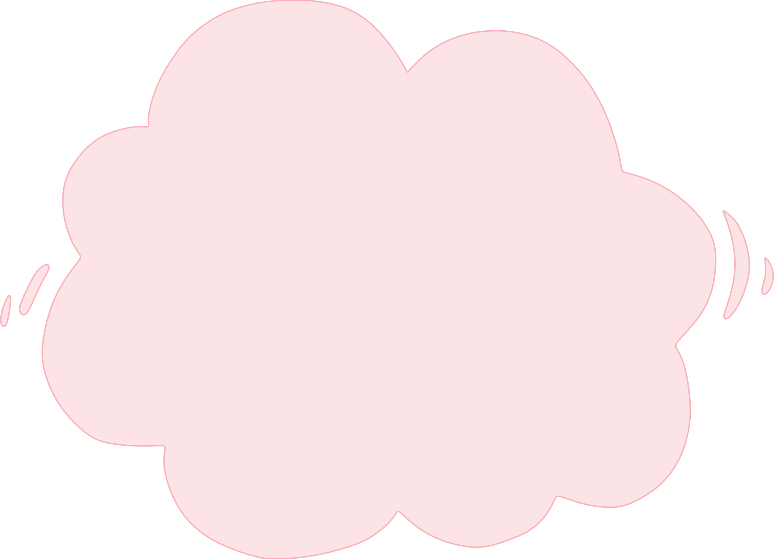

Wednesday

Tuesday

Friday

*For Kids*



**Instructions for Use**

**To use this template, please adhere to the conditions outlined below.**

**You are allowed to:**

**-** Modify this template to suit your needs.

**-** Employ this template for both personal and commercial projects.

**You are not allowed to:**

**-** Sublicensing, selling, or renting this template or any modified versions thereof.

**-** Distributing the Template or any modified versions or including it in a collection such as a database or any other product or service that offers downloadable assets (e.g., images, icons, templates) for redistribution or resale.

**-** Utilizing any individual elements of this template in isolation from the template itself.

**-** Registering any part of this template as a trademark or logo or claiming any part as your own intellectual property in any registry or similar entity.

**For detailed information, please review our** [**Terms and Conditions**](https://www.highfile.com/terms-of-use/)**.**

**Fonts Used:**

* ABeeZee: <https://fonts.google.com/specimen/ABeeZee>
* Chilanka:<https://fonts.google.com/specimen/Chilanka>