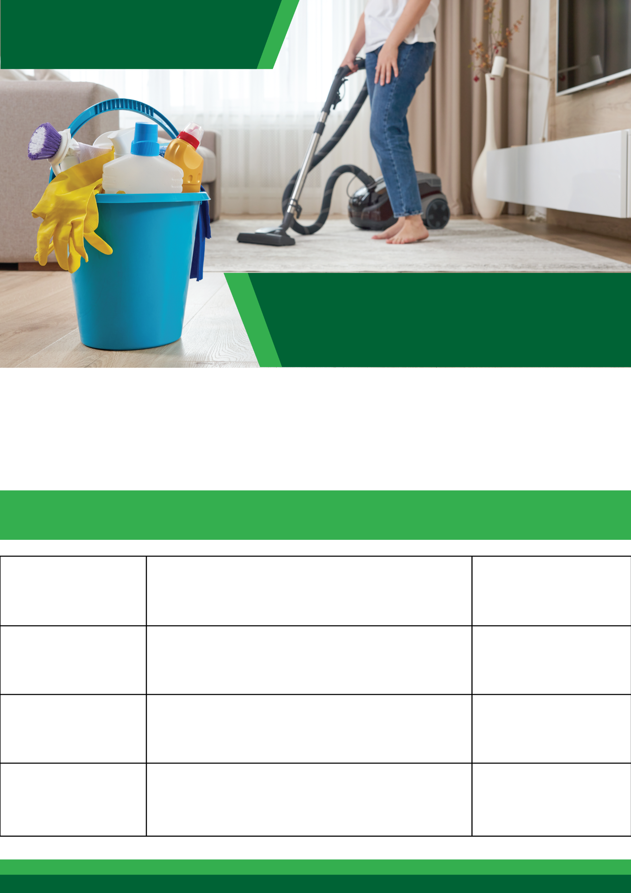

**BRAND NAME**

**Tagline here**

**Cleaning Services**

**Professional**

**Cleaning Service Price List**

www.emailaddress.com

111-222-3334

**DESCRIPTION**

**SERVICE**

**PRICE RANGE**

**$ 30 - $ 40**

**$ 30 - $ 40**

**$ 30 - $ 40**

**$ 30 - $ 40**

**Lorem ipsum**

**Lorem ipsum**

**Lorem ipsum**

**Lorem ipsum**

Lorem ipsum dolor sit amet, con-

sectetuer adipiscing elit, sed

diam nonummy nibh euismod

Lorem ipsum dolor sit amet, con-

sectetuer adipiscing elit, sed

diam nonummy nibh euismod

Lorem ipsum dolor sit amet, con-

sectetuer adipiscing elit, sed

diam nonummy nibh euismod

Lorem ipsum dolor sit amet, con-

sectetuer adipiscing elit, sed

diam nonummy nibh euismod