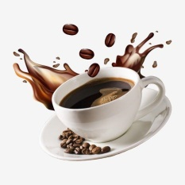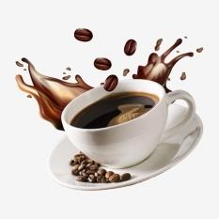

TERMS & CONDITIONS

THIS CERTIFICATE IS STRICTLY NOT FOR SALE AND IS VALID FOR ONE-TIME USE ONLY. VALID UNTIL DECEMBER 17, 2023.

STAN’S COFFEE & BEANS

Gift Certificate

FREE ONE COFFEE FOR YOU

TERMS & CONDITIONS

THIS CERTIFICATE IS STRICTLY NOT FOR SALE AND IS VALID FOR ONE-TIME USE ONLY. VALID UNTIL DECEMBER 17, 2023.

STAN’S COFFEE & BEANS

Gift Certificate

FREE ONE COFFEE FOR YOU