Call Sheet #1 - Thursday 25th January 2013

Film Title
Unit Call Time: 08:00 |  | Weather:  Temp:  Sunrise:  Sunset:  Humidity | Cloud / Sun / Chance of rain  Highs of 23 degrees  05:06  20:57  60-70%
Main Production Contact |  | Name & Number
Director:  Line Producer:  Camera:  Production Assistant:  Client Contact:  Location Contact: | Name  Name  Name  Name  Name  Name | Number  Number  Number  Number  Number  Number |  | Email  Email  Email  Email  Email  Email

Preliminary Schedule - Subject to change
Time | Action
08:00  09:00  12:00  18:00  19:00 | Unit Call & Setup  Roll Camera  Lunch  Wrap  Crew leave | Unit Wrap Time: 18:00

Location
Starboard Media Ltd  57 Albert Road  Portsmouth  PO5 2SF  Tel: 02392 369206 | 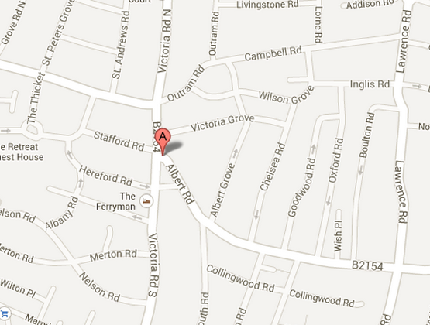

Health & Safety
- All crew to wear protective footwear (No flip flops, sandals or open toe shoes)
- All crew to wear sensible clothing (No shorts. Only jeans or long trousers permitted)
Full risk assessment attached.

Production Requirements
Rushes: To be downloaded and backed up on set. Parking: On site
Catering: XX to provide lunch for Crew
Toilets: On set
Medical: On set

