
AmeriCorps Childcare Attendance Sheet Invoice

Member Name: _______________________________________________ |  |  | Member E-Mail Address: ____________________________________
Provider Name: ____________________________ |  | ___ | Provider E-Mail Address: ___________________________________
Month of Care: _________________________________ |  |  | Year of Care: ______________________________ State: __________
TABLE A: CHILDREN IN CARE
Child Name |  | Age |  | Child Care Provider Rate (ex: $100/weekly)
1.
2.
3.
4.

*Please type the letter “A” for days that your child is absent or sick, type “H” for Holidays and “W” for weekends*
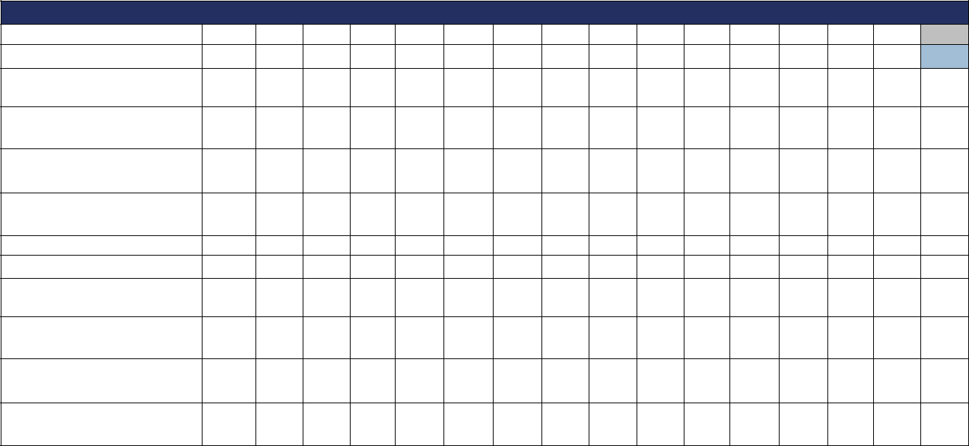

TABLE B: Fill in the # of hours each day care was provided

Days of the Month |  | 1 |  | 2 |  |  | 3 |  | 4 |  |  | 5 |  |  | 6 |  | 7 |  | 8 |  |  | 9 | 10 |  | 11 |  | 12 |  | 13 | 14 |  | 15

Child 1:

Child 2:

Child 3:

Child 4:

Days of the Month |  | 16 | 17 |  | 18 | 19 |  | 20 |  | 21 | 22 | 23 |  | 24 | 25 |  | 26 |  | 27 |  | 28 | 29 |  | 30 | 31

Child 1:

Child 2:

Child 3:

Child 4:

In the table below, please add up your weekly charges for the month


TABLE C: INVOICE CHARGES

 |  | WEEK 1 | $
 |  | WEEK 2 | $
 |  | WEEK 3 | $
 |  | WEEK 4 | $
 |  | WEEK 5 | $
 |  | TOTAL INVOICE CHARGES | $
X
Provider Signature |  |  |  |  | Date

I certify that the provider information and attendance record entered on this attendance sheet are true and accurate. I understand that my payment will be in accordance with the CCDF Block Grant program guidelines for my state. I further understand that any misrepresentation of information may result in legal action.

X

Member Signature Date
I certify that the information provided above and the attendance records entered on this attendance sheet are true and accurate. I

understand that my payment will be in accordance with the CCDF Block Grant program guidelines for my state. I further understand that any misrepresentation of information may result in legal action.

*Upon receipt of a completed Attendance Sheet, payment will be made within 10 calendar days (Incomplete attendance sheets will NOT be processed)
Form Updated September 2016

