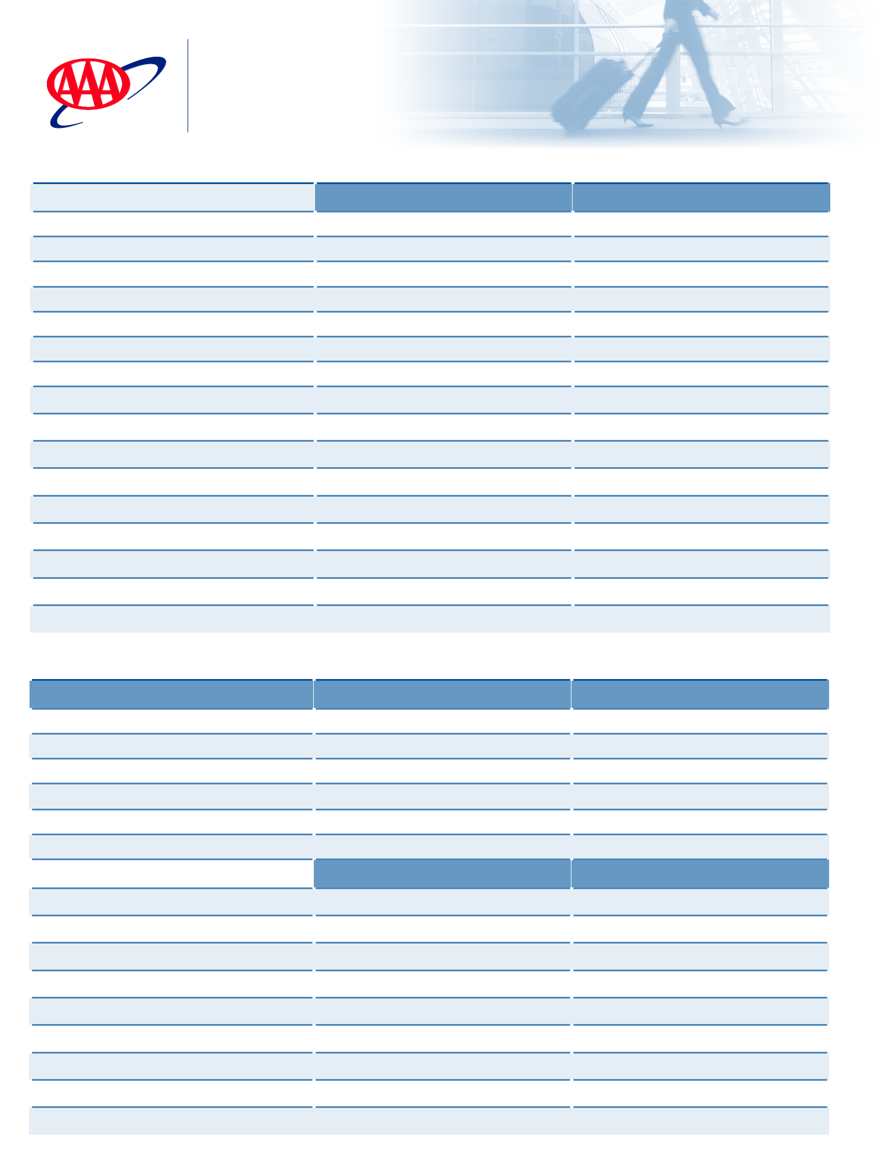
THE SEASONED TRAVELER
Packing List

Carry-On | Handbag or Carry-On
£ Rx Medications | Documentation | Electronics
£ Birth Control | £ Passport | £ Phone
£ Contacts/Case | £ Driver’s License | £ Camera (film if needed)
£ Antacid | £ Tickets | £ Laptop/Tablet
£ Pain Reliever | £ Credit/ATM Cards | £ Chargers
£ Makeup | £ Foreign Currency | £ Converter (if needed)
£ Makeup Remover (3.4 oz.) | £ Itinerary/Maps | £ Memory Card
£ Moisturizer (3.4 oz.) | £ Health/Travel Insurance | £ Video Camera
£ Sunscreen (3.4 oz.) | £ Books/Reading Material
£ Cotton Rounds | £ Emergency Contact List
£ Toothbrush | £ Tissues
£ Dental Floss | £ Lip Balm
£ Deodorant | £ House Keys/Car Keys
£ Ear Plugs | £ Sunglasses
£ Sleep Mask | £ Reading Glasses
£ Valuable Jewelry | £ Healthy Snack
£ Extra Pair of Underwear
Luggage
Clothing | Accessories | Outdoor Wear
£ Sleepwear | £ Belts | £ Bathing Suit
£ Robe/Slippers | £ Ties | £ Umbrella
£ Underwear | £ Scarves | £ Raincoat
£ Socks/Stockings | £ Anti-theft bags | £ Warm Jacket
£ Undershirts/Bras | £ Jewelry | £ Gloves/Mittens
£ Dress Shirts
£ Casual Shirts | Comforts-of-Home | Sports/Special Gear
£ Evening Jacket | £ Tissues
£ Pants | £ Tweezers
£ Shorts | £ Nail Clippers
£ Skirts | £ First-aid Kit
£ Dresses | £ Cotton Swabs
£ Athletic Shoes | £ Hair Products
£ Walking Shoes | £ Hair Dryer
£ Evening Shoes
£ Hat

©2014 AAA Mid-Atlantic Mktg # 14_628

