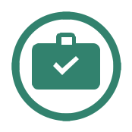
The Ultimate

Travel Checklist


Preparing to travel | Done?


Renew/ check passport

Obtain relevant visas

Ensure you have recommended vaccinations

Purchase travel insurance

Print off documents

Check-in online with airline

Check flight times

Check baggage weight

Personalise luggage

Change money

Notify your bank that you are travelling to avoid having cards declined
Make a note of numbers to call to cancel cards Check local weather/news in destination

Email a copy of all documents to yourself in case of theft


Documents | Ready?Packed?


Passport

Extra passport photos

Vaccination certificates

Driver’s license

Discount cards

Hostel/hotel reservations and contact information

Travel insurance documents

Travel itinerary and reservations

Tickets (flight/boat/bus)

Photocopies of documents/ID/tickets

Emergency contact info


Money | Ready?Packed?


Sterling (for use in the airport)

Foreign currency

Emergency cash (US$100)

Credit card

Debit card

Pre-paid currency card

Wallet

Money belt (that can be concealed beneath clothes)


Bags | Ready? | Packed?
Main, large rucksack or suitcase |  | n/a
Carry-on bag (small day pack) |  | n/a
Waterproof cover for rucksack


Clothes

Jumper/fleece

Jeans/trousers

Shorts

Skirts/dresses

Shirts (strappy/polo/t-shirts/casual/smart)

Raincoat

Bras

Underwear

Socks (thin and thermal)

Pyjamas

Thermal underwear


Swimwear

Swimming shorts/swimsuit/bikini Sarong


Shoes

Flip flops/sandals

Trainers

Walking boots

Smart shoes


Accessories


Sunglasses/case/strap

Watch

Belt

Scarf

Gloves

Hat

Travel towel

Small umbrella


Sleeping

Sleeping bag

Sleeping bag liner

Ready? Packed?

Ready? Packed?

Ready? Packed?

Ready? Packed?

Ready? Packed?

1 www.projects-abroad.co.uk

The Ultimate
Travel Checklist


Toiletries
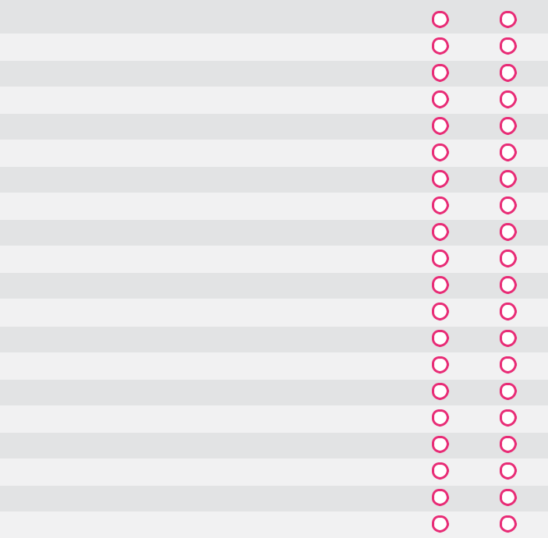

Toiletry bag

Skin care/lotion

Make-up

Toothbrush/toothpaste

Tissues

Feminine hygiene items

Deodorant

Hair brush/comb

Shampoo/conditioner

Soap/cleansers

Cotton buds

Tweezers

Baby wipes

Shaving gel/foam

Razor/electric shaver

Nail clippers/file

Wash cloth

Dental floss

Perfume/aftershave

Make-up remover


Healthcare

Painkillers

Prescription medication
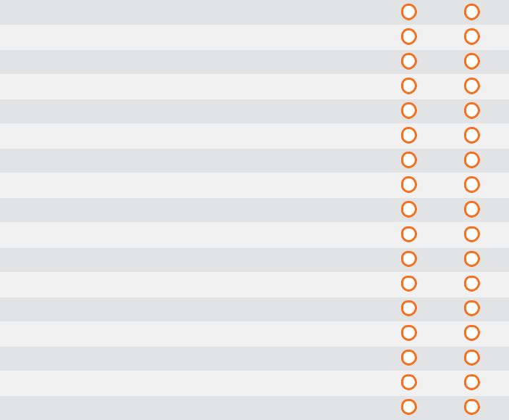

First aid kit

Sterile needle kit

Diarrhoea medicine

Rehydration sachets (e.g. Dioralyte)

Anti-malarial medication

Contraception (pill/condoms)

Lip balm

Sun cream

After-sun

Cold/flu medicine

Vitamins

Hand sanitiser

Insect repellent

Antiseptic cream

Plasters

Water purifier (e.g. Iodine)

Ready? Packed?

Ready? Packed?

Electronics and gadgets

Travel adaptors

Mobile phone and charger

Camera and charger

SD cards

Rechargeable batteries

Laptop/tablet and charger

External battery charger

USB cables

iPod

Travel alarm

Head torch

Torch

Extra batteries

Binoculars

Travel hairdryer

E-reader
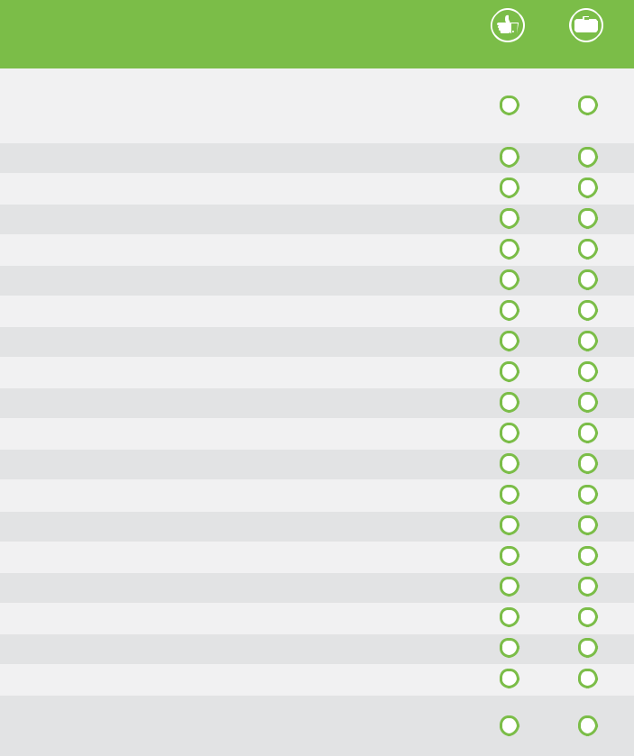

Other

Waterproof stuff sacks (for holding gadgets and

small items)

Knife/fork/spork

Portable door lock

Extra backpack fasteners

Sewing kit

Plastic bags/black sacks

Packing cubes

Ear plugs

Pocket knife/multi-tool

Pens

Pack of cards

Travel games

Travel sweets

Chewing gum

Books

Phrase books

Guide books

Water bottle/platypus

Universal travel sink plug

Bungee rope (to act as clothes line or to attach

things to backpack)


Travel pillow

Padlocks (combination rather than key)

Journal

Compass

Duct tape

Energy bars

Travel wash

Ready? Packed?

Ready? Packed?

2 www.projects-abroad.co.uk

