SUMMER TRIP PACKING LIST

Going to: For how long: Date leaving:


CLOTHES

2 dresses or 2 skirts

1 pair of jeans

3 pairs of shorts

4 t-shirts

3 tank tops

2 dressy tops

2 bathing suits

1 set of workout

clothes

1 set of pajamas

SHOES

1 pair of ip- ops

1 pair of sandals

1 pair of dressy sandals

1 pair of sneakers

OUTERWEAR

1 denim jacket

1 rain jacket

1 sweatshirt

1 sweater/cardigan

MUST-HAVES

10 pairs of

underwear

4 bras

5 pairs of

socks

TOILETRIES

toothpaste

toothbrush

oss

deodorant

shampoo

conditioner

soap

face wash

makeup

makeup remover

sunscreen

lotion/moisturizer

hair products

chapstick

razor/shaving

cream

contact solution
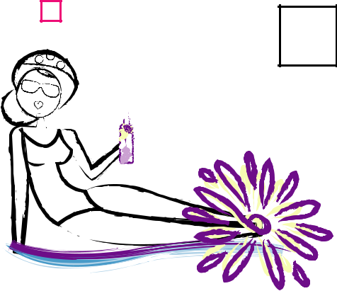

pads/tampons

ACCESSORIES

sunglasses

belt

hat

umbrella
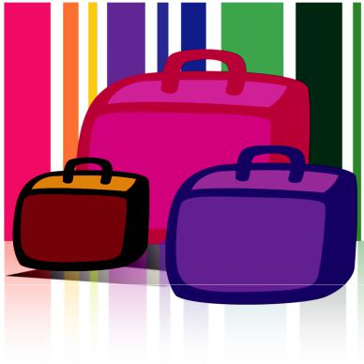

EVERYTHING

ELSE

medicine/vitamins

phone charger

passport

itinerary

ENTERTAINMENT

headphones

book/magazines

ipad/ipod/kindle/charger

