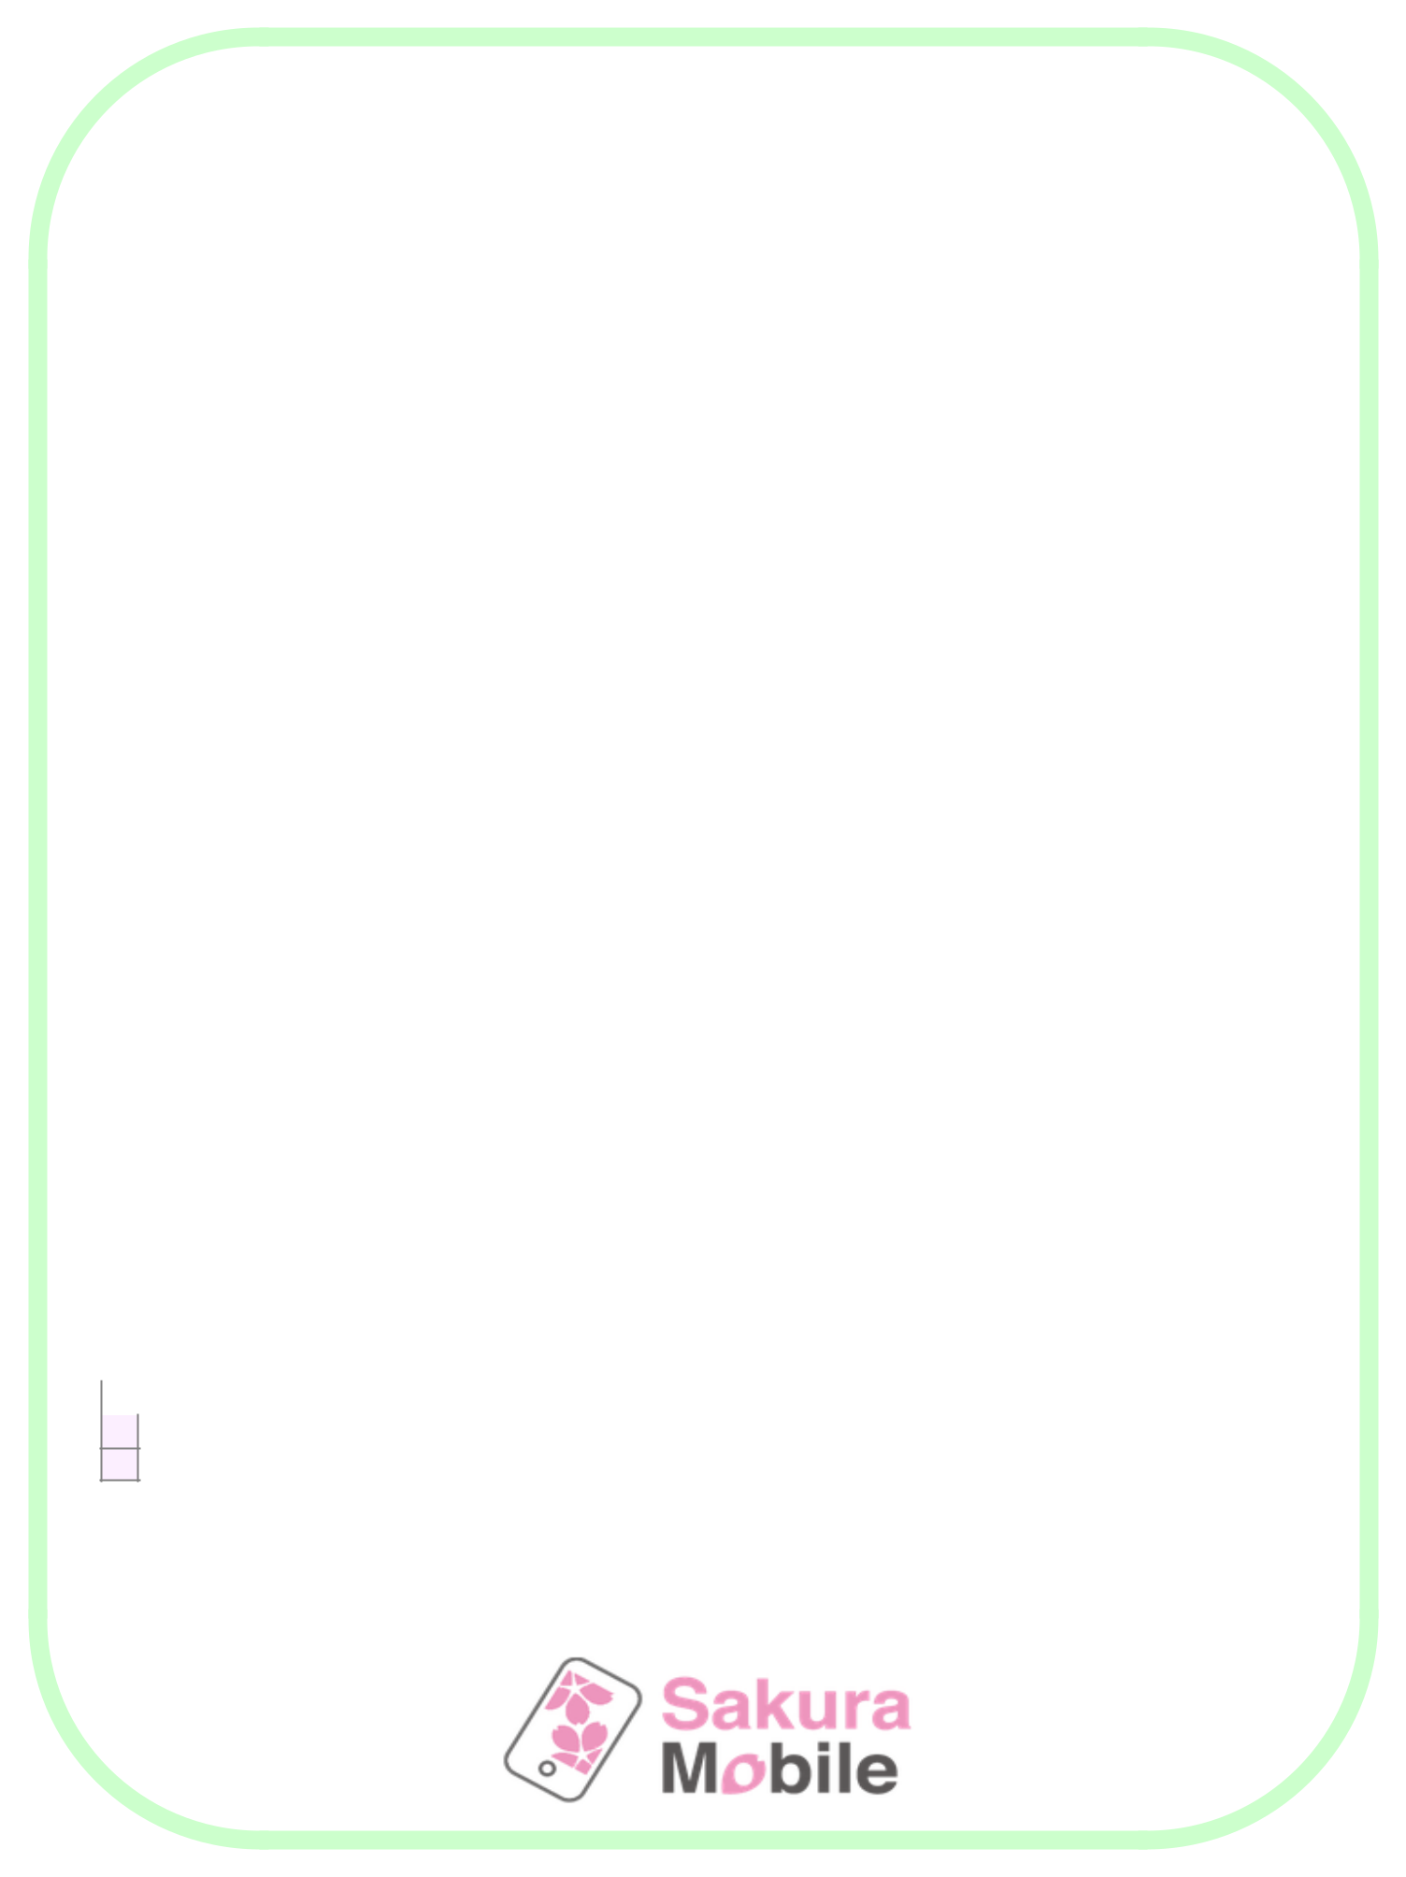
What to Pack for Japan

 |  |  |  | = Can easily be purchased in Japan
 | Clothing |  |  | Personal Hygiene |  |  |  | Documentation
 | Casual Shirts / T-Shirts |  |  | Dental Care |  |  |  | Travel Itinerary
 | Casual Pants / Shorts |  |  | Razor / Shave Gel |  |  |  | Visa / Passport
 | Pajamas / Slippers |  |  | Cotton Swabs |  |  |  | Attraction Tickets
 | Sweater(s) |  |  | Tweezers |  |  |  | Plane Ticket Reservation
 | Undergarments |  |  | Deodorant |  |  |  | International License
 | Socks |  |  | Shampoo & Conditioner |  |  |  | Sakura Mobile SIM / WiFi
 | Shoes / Sandals |  |  | Soap / Body Wash |  |  |  | Reservation
 | Belt |  |  | Hairbrush
 | Hats / Scarves / Gloves |  |  | Hair Products
 | Jacket / Coat |  |  | Sunscreen & Lotion
 | Swimwear |  |  | Cologne / Perfume |  |  |  | Baby / Child Items
 | Workout Clothes / Shoes |  |  | Cosmetics |  |  |  | Snacks & Wipes
 | Smart-Casual Clothing |  |  | Skincare Products |  |  |  | Clothes / Socks / Shoes
 | Nylons |  |  | Feminine Products |  |  |  | Coat / Hat / Gloves
 |  |  |  | Glasses / Case / |  |  |  | Favorite Pillow
 |  |  |  | Contacts / Solution |  |  |  | Games / Toys / Stuffed
 |  |  |  | Hand Towels |  |  |  | Animals
 | Travel Aid |  |  |  |  |  |  | Coloring Books / Crayons
 | Travel Pillow |  |  |  |  |  |  | / Pencils
 | Mp3 Player |  |  |  |  |  |  | Clothes / Socks / Shoes
 | Earplugs |  |  | Medication |  |  |  | Diapers
 | Eye Mask |  |  | Allergy Medication |  |  |  | Diaper Ointment
 |  |  |  | Multivitamins |  |  |  | Baby Shampoo / Soap
 |  |  |  | Hand Sanitizer |  |  |  | Nursing Cover / Breast
 |  |  |  | Pain Medication |  |  |  | Pump
 | Electronic Devices |  |  | Digestive Medication |  |  |  | Formula
 | Smartphone / Cell Phone |  |  | Prescription Medication |  |  |  | Bottles / Sippy Cup
 | Camera & Accessories |  |  | (research restrictions) |  |  |  | Blanket
 | Laptop / Tablet |  |  |  |  |  |  | Baby Carrier
 | Power Adapters |  |  |  |  |  |  | Toys
 |  |  |  |  |  |  |  | Swimwear
 |  |  |  | Miscellaneous |  |  |  | Swim Diapers
 |  |  |  | Small Gifts
 | Daily Essentials |  |  | Japanese Dictionary
 | Money (for exchanging)

Purse / Wallet / Fanny

Pack

