

women Clothes

men
Packing Checklist


Traveler’s Name

Departure Date

 | Destination |  |  | Days |  |  | Local Weather
Click on items in blue to shop the Category
 | Basics |  |  | Dressy |  |  |  | Casual |  |  | Outerwear & Accessories
 |  |  | Bras & Underwear |  |  | Dresses |  |  |  | T-shirts |  |  |  | Jackets & Coats
 |  |  | Socks |  |  | Skirts |  |  |  | Tank Tops |  |  |  | Raincoats
 |  |  | Sleepwear |  |  | Slacks |  |  |  | Jeans |  |  |  | Hats & Gloves
 |  |  | Robe |  |  | Long Sleeve Shirts |  |  |  | Shorts |  |  |  | Scarves
 |  |  | Slippers |  |  | Blazers |  |  |  | Swimsuit |  |  |  | Belts
 |  |  | Sandals/Flip Flops |  |  | Sweaters |  |  |  | Casual Shoes |  |  |  | Jewelry
 |  |  |  |  |  | Dress Shoes
 |  |  | Underwear & |  |  | Pants |  |  |  | T-Shirts & Polos |  |  |  | Jackets & Coats
 | Sleepwear |  |  |  |  | Long Sleeve Dress Shirts |  |  |  | Short Sleeve Shirts |  |  |  | Raincoats
 |  |  | Socks |  |  | Sweaters |  |  |  | Jeans |  |  |  | Hats
 |  |  | Robe |  |  | Blazers |  |  |  | Shorts |  |  |  | Gloves
 |  |  | Slippers |  |  | Ties |  |  |  | Swimsuits |  |  |  | Belts
 |  |  | Sandals/Flip Flops |  |  | Dress Shoes |  |  |  | Casual Shoes
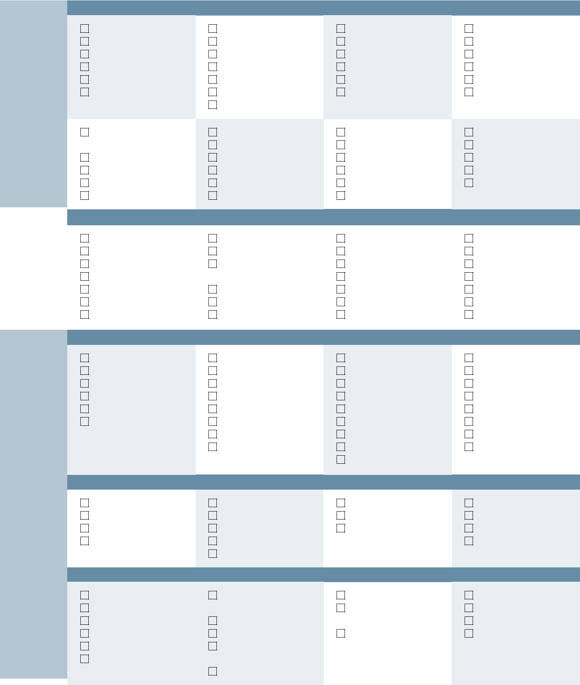

toiletries

Toiletries

Toothbrush |  | Soap |  | Brush or Comb |  | Contact Lenses & Supplies
Toothpaste (3 oz) |  | Washcloth |  | Hair Products |  | Birth Control
Dental floss |  | Shampoo & |  | Mirror |  | Feminine Hygiene
Mouthwash (3 oz) |  | Conditioner (3 oz) |  | Sunscreen (3 oz) |  | Medications
Deodorant (3 oz) |  | Nail Care Supplies |  | Moisturizer (3 oz) |  | Vitamins
Cotton Balls/Swabs |  | Shaving Supplies |  | Lip Balm |  | Pain Reliever/Aspirin
Tweezers |  | Makeup Remover |  | Insect Repellent |  | First-Aid/Band-aids

travel essentials

Travel Aids |  | Travel Info |  |  | Documents |  |  | Miscellaneous
 | Pleasure reading |  |  | Passport/Visa |  |  | Copies of Travel Docs |  |  | Umbrella
 | Snacks |  |  | Driver’s License |  |  | Copies of Credit Cards |  |  | House Keys
 | Earplugs |  |  | Itinerary |  |  | Copies of Passport |  |  | Travel Locks & Keys
 | Sleeping mask |  |  | Maps & Directions |  |  | Credit Card Contact Info. |  |  | Luggage Tags
 | Travel Pillow & Blanket |  |  | Travel Confirmation |  |  | Emergency Contact Info. |  |  | Hospitality Gifts
 | Motion-sickness |  |  | Membership Cards |  |  | Medical Insurance Card |  |  | Journal
 | Remedy |  |  | Guidebook |  |  | List of Medications |  |  | Pens/Pencils
 |  |  |  | Language Guide |  |  | Travel Insurance |  |  | Sense of Humor
 |  |  |  |  |  |  | Int. Vaccination Card

Funds |  | Bags |  |  | Packing Aids |  |  | Laundry
 | Wallet |  |  | Backpack/Daypack |  |  | Packing Cubes |  |  | Laundry Bag
 | Cash |  |  | Purses |  |  | Packing Folders |  |  | Laundry Kit
 | Credit Cards |  |  | Collapsible Tote |  |  | Compression Socks |  |  | Sewing Kit
 | ATM Card |  |  | Money Belt |  |  |  |  |  | Stain Remover
Technology |  |  |  | Sealable Plastic Bags | Contacts |  |  | Work
 | Cellphone & Charger |  |  | Small Flashlight/ |  |  | Address Book |  |  | Work Documents
 | PDA & Charger |  |  | Headlamp |  |  | Important Numbers/ |  |  | Work Reading
 | Laptop & Charger |  |  | Binoculars |  |  | Datebook |  |  | Office Supplies
 | Camera & Charger |  |  | Alarm Clock |  |  | Calling Card |  |  | Notebook
 | Film or Memory Card |  |  | Music Player &
 | Adapters & Converters |  |  | Headphones
 |  |  |  | Kindle/iPad

For expert packing advice call: 800.770.3387 or visit: www.travelsmith.com

