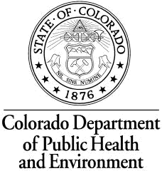
Laboratory Services Division - Packing Slip
All packages sent to the CDPHE Laboratory Services Division must include a specimen packing slip, printed transfer log or shipping manifest.

The Laboratory Services Division will verify package contents with the enclosed packing slip. If contents are missing from the shipment, you will be notified immediately.
If the shipment is received after 4 p.m., you will be notified the next business day.

Ship To: From:

CDPHE Laboratory Services Division Contact Name:
8100 Lowry Blvd. Phone:
Denver, CO 80230 E-mail:
Company:
ATTN: Sample/Specimen Receiving Address:
City, State, Zip:
Shipping Method:
Customer Number (if known)
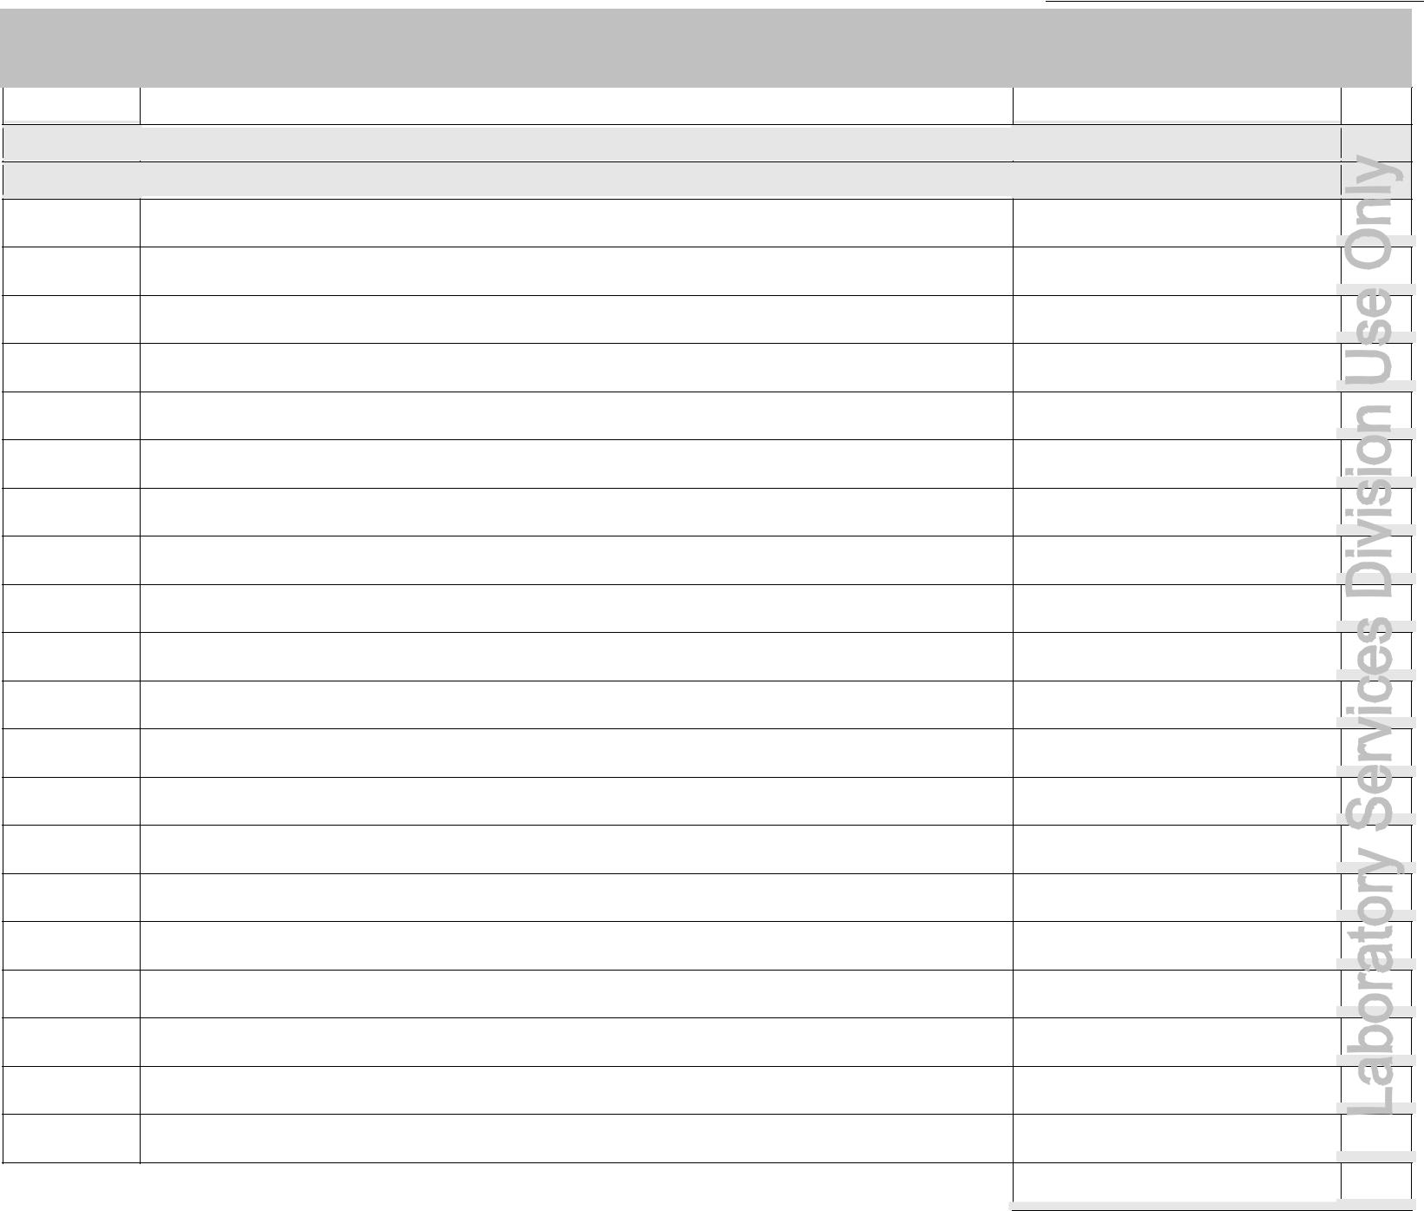
This packing slip does not take the place of a requisition form.

Please verify that requisition forms for each specimen are included in this shipment.

 | Quantity |  |  |  |  | Kit Type - or - Description of Specimen/Sample - or - Patient Name |  |  |  |  | ID number(s)* |  |  |  | ✓
 |  | 1 | [Example] |  |  |  | Serum – Jack B. Nimble | #52307
 |  | 1 | [Example] |  |  |  | Water Test Kit | #1009
 |  |  |  |  | *ID number = number on specimen or sample
 |  |  |  |  |  |  |  |  |  |  | LSD receiving initials |  | →

Page of

