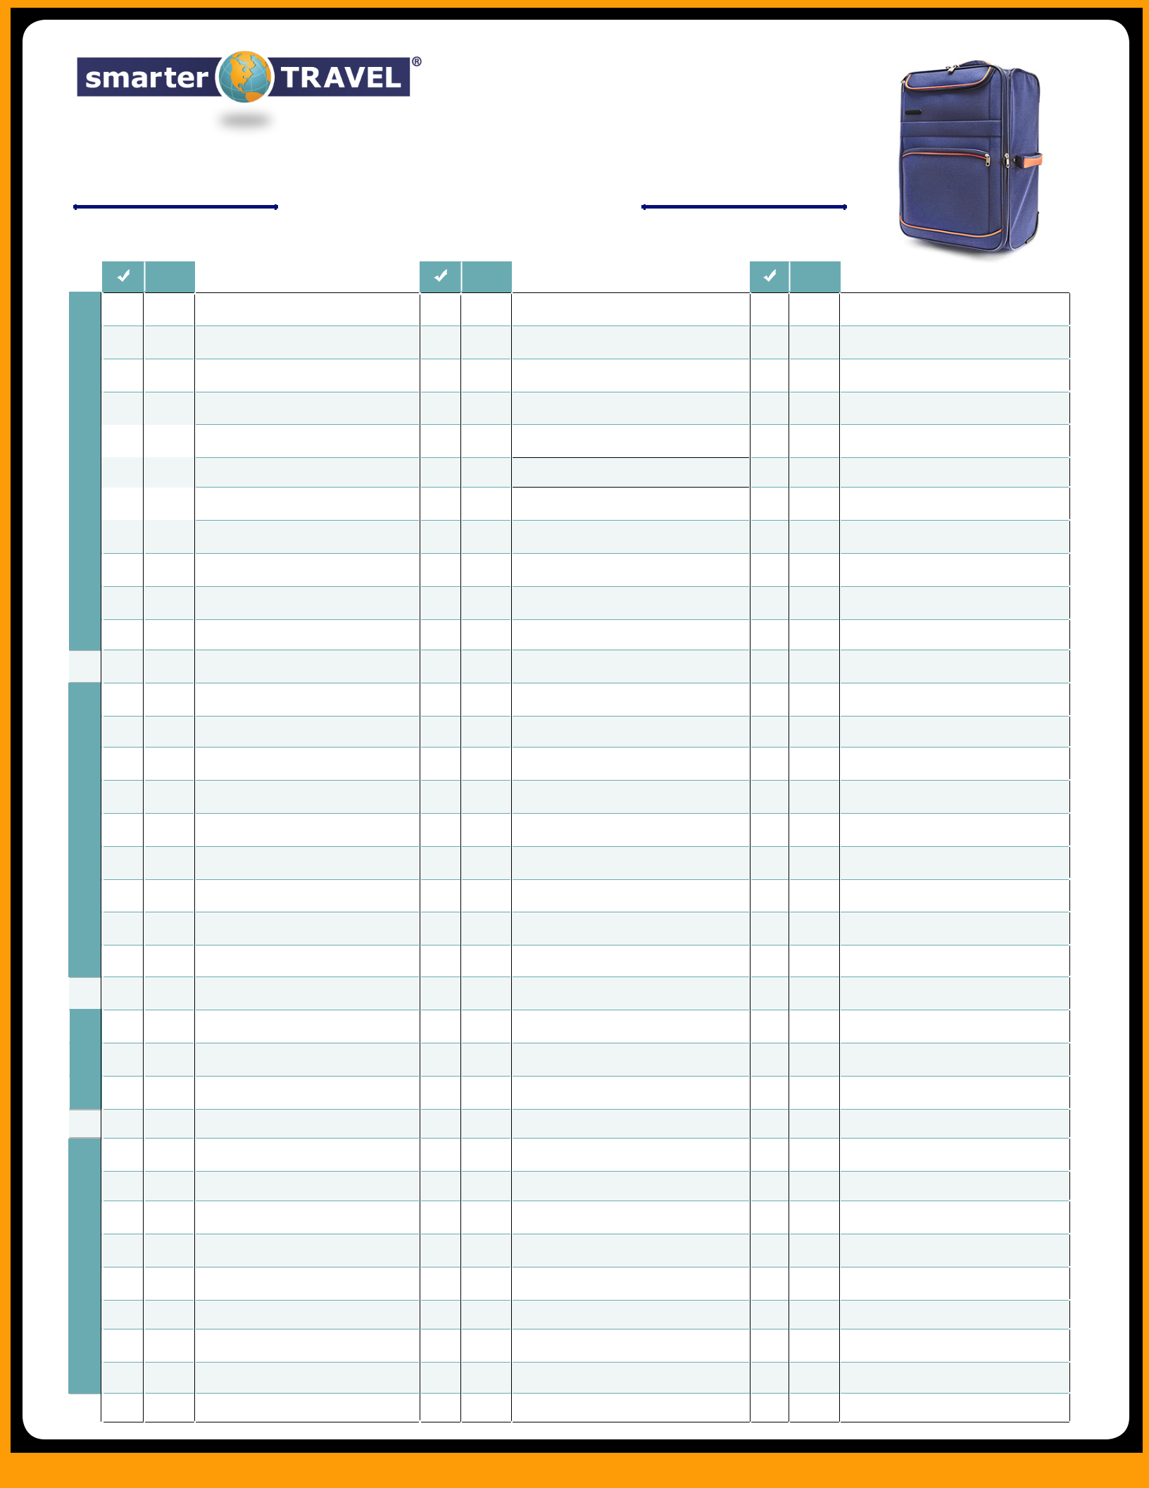
THE ULTIMATE
Packing List

qty

CLOTHES

Underwear
Socks/stockings

Undershirts/bras
Sleepwear

T-shirts
Dress shirts
Casual shirts

Jeans
Pants

Shorts
Dresses

qty

Skirts
Sweaters/sweatshirts

Suits
Swimsuits/cover-ups

Coats/jackets/rainwear
Hats
Gloves

Scarves
Umbrella

Laundry kit (soap, stain remover)

Laundry bag

qty

Leisure shoes
Hiking/athletic shoes

Snow/rain boots
Dress shoes

Sandals/flip-flops
Belts

Ties

Jewelry (if valuable, put in carry-on)

Purses
Collapsible totes

Under-clothing document holders

 | Toothbrush
 | Toothpaste
TOILETRIES | Dental floss
TOILETRIES | Soap
 | Deodorant
 | Shampoo/conditioner
 | Brush/comb
 | Hairstyling appliances
 | Face cleanser
MISC. | Cell phone
MISC. | Laptop/tablet
 | Electronics chargers
 | Books or e-books
 | Video/MP3 player
ON | Earbuds/headphones
ON | Pashmina/travel blanket
CARRY- | Pashmina/travel blanket
CARRY- | Ear plugs/eye mask
 | Travel pillow
 | Tissues
 | Lip balm

Face lotion/gel/etc.
Sunscreen
Moisturizer

Contact lenses/solution
Shaving supplies

Makeup
Makeup remover

Feminine-hygeine products
Birth control

Voltage adaptor
Film/memory card

List of medications

Change of clothes
Food/snacks/gum

Empty water bottle (fill post-security)

In-flight medications
Valuables, such as jewelry

Camera
Passport/visa/ID

Paper/pen

Nail file/clippers
Tweezers

Hand sanitizer
Bandages

First-aid ointment
Insect repellant

Medications
Pain relievers

Vitamins

Emergency contacts Credit-card/bank contacts

Copies of passport/credit card/etc.

Cash
Credit/ATM cards

Insurance cards (medical, travel)

Itinerary
Maps/directions

Guidebook
Address book

House keys

©2013 Smarter Travel Media, LLC. All Rights Reserved.

